**Inventory. Walmart places road master bike order every 3 months from manufacturer and stocks them at their store for sale. As Fall semester is about to start in August, their business analysts came up with 3 months demand figures as follows: August, 40 bikes; September, 45 bikes; October, 35 bikes. Based on the demand, manufacturer’s price per bike fluctuates as follows: August, $90; September, $95; October, $90. Walmart’s inventory management team assessed that, by holding a bike in their inventory at the end of each month, Walmart loses $5 opportunity cost per bike which is a holding cost. As these 3 months follow seasonal effect, Walmart’s selling price fluctuates as** **follows: August, $90; September, $95; October, $99. At the beginning of month August, Walmart will be having 10 bikes on hand. Determine how procurement department place the order for these 3 months in order to maximize their profit. Orders will reach Walmart store on Day 1 of every month.**

**Discussion.**

The unique aspect of this problem lies in identifying the calculated or abstract parameters that are not explicitly mentioned in the input and drafting a balancing equation for them. That means, calculated parameters are those parameters that flow through the timeline of the problem, keeps updating itself by the balancing equation and impacts the objective and the decision variables. In this case, orders reach the store on Day 1 of every month. Note that there can be an initial inventory as in this case before the starting month too. It only means that, to satisfy demands of month 1, we can utilize products ordered for month 1 as well as the initial inventory (i.e. Inventory from month 0, $I_{O})$. The holding cost is the cost to store the products in inventory i.e., maintenance cost and opportunity cost. This cost further adds to the total cost incurred.

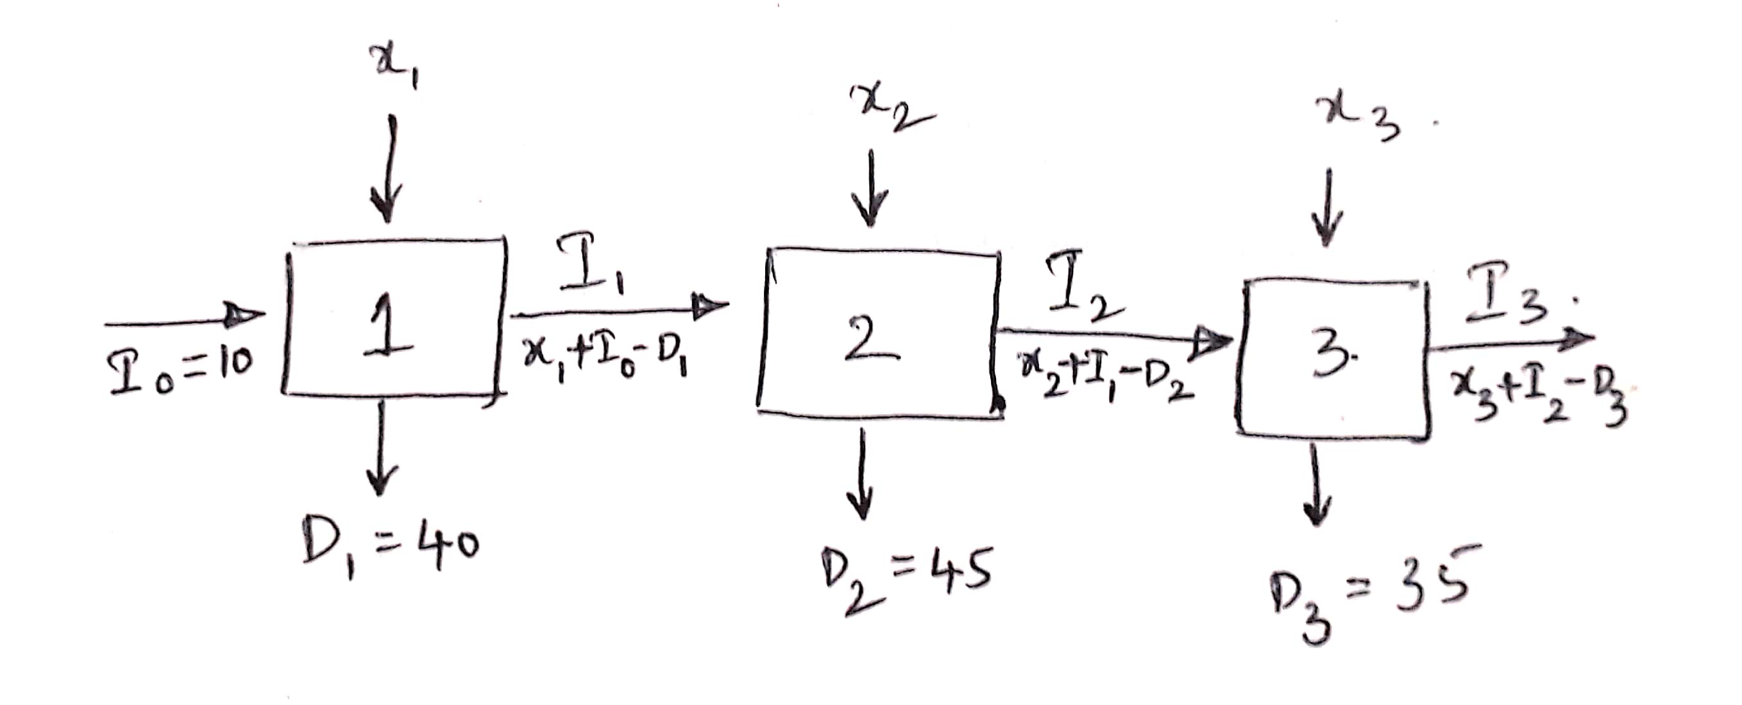

**Model.**

Parameters:

$D_{i }$: *Demand for month $i$, $where i∈\left(1,2,3\right)$*

$C_{i}$: *Unit cost price for month $i$, $where i∈\left(1,2,3\right)$*

$S_{i}$: *Unit selling price for month $i$, $where i∈\left(1,2,3\right)$*

$H$: *Unit holding cost*

$α$: *Fraction of the bikes ordered for a month that can be used to meet the current month’s demand (here $α=100\%)$*

$I_{O}:$*Initial inventory*

Decisions:

$x_{i }$: *Units of bikes to be ordered for month $i$, $where i∈\left(1, 2, 3\right)$*

Calculated Parameters:

$I_{i}:$*Inventory at the end of month $i$, $where i∈\left(1,2,3\right)$*

$I_{i}$ = $I_{i-1}$ + $x_{i}$- ${ D}_{i }$

Objective: *Maximize Profit*

+ *

Constraints:

$x_{i }≥0 \left(1\right)$ Units of bikes ordered cannot be negative.

2) Inventory balancing equation for every month.

Notes:

1. The problem states that all the units ordered for a month can be used to meet the demand of that month. Hence constraint 2 is an inventory balancing equation which ensures that inventory of previous month can be used for current month’s demand.
2. In theory, we can use $I_{i} ≥ 0$, which means that demand of each month is satisfied, i.e.

+ , sum of inventory flown in from previous month and current month’s order must satisfy the current month’s demand. But in reality, not all the products ordered for a month can be used to satisfy the demand of that month since orders can reach the warehouse throughout the course of the month, and at a particular moment in time in the month, not all units that are ordered will be available. To account for this, the second equation considers only a fraction (Full in this case) of the units ordered for a month to be available to satisfy the demand of that month. See figure below for further illustration.

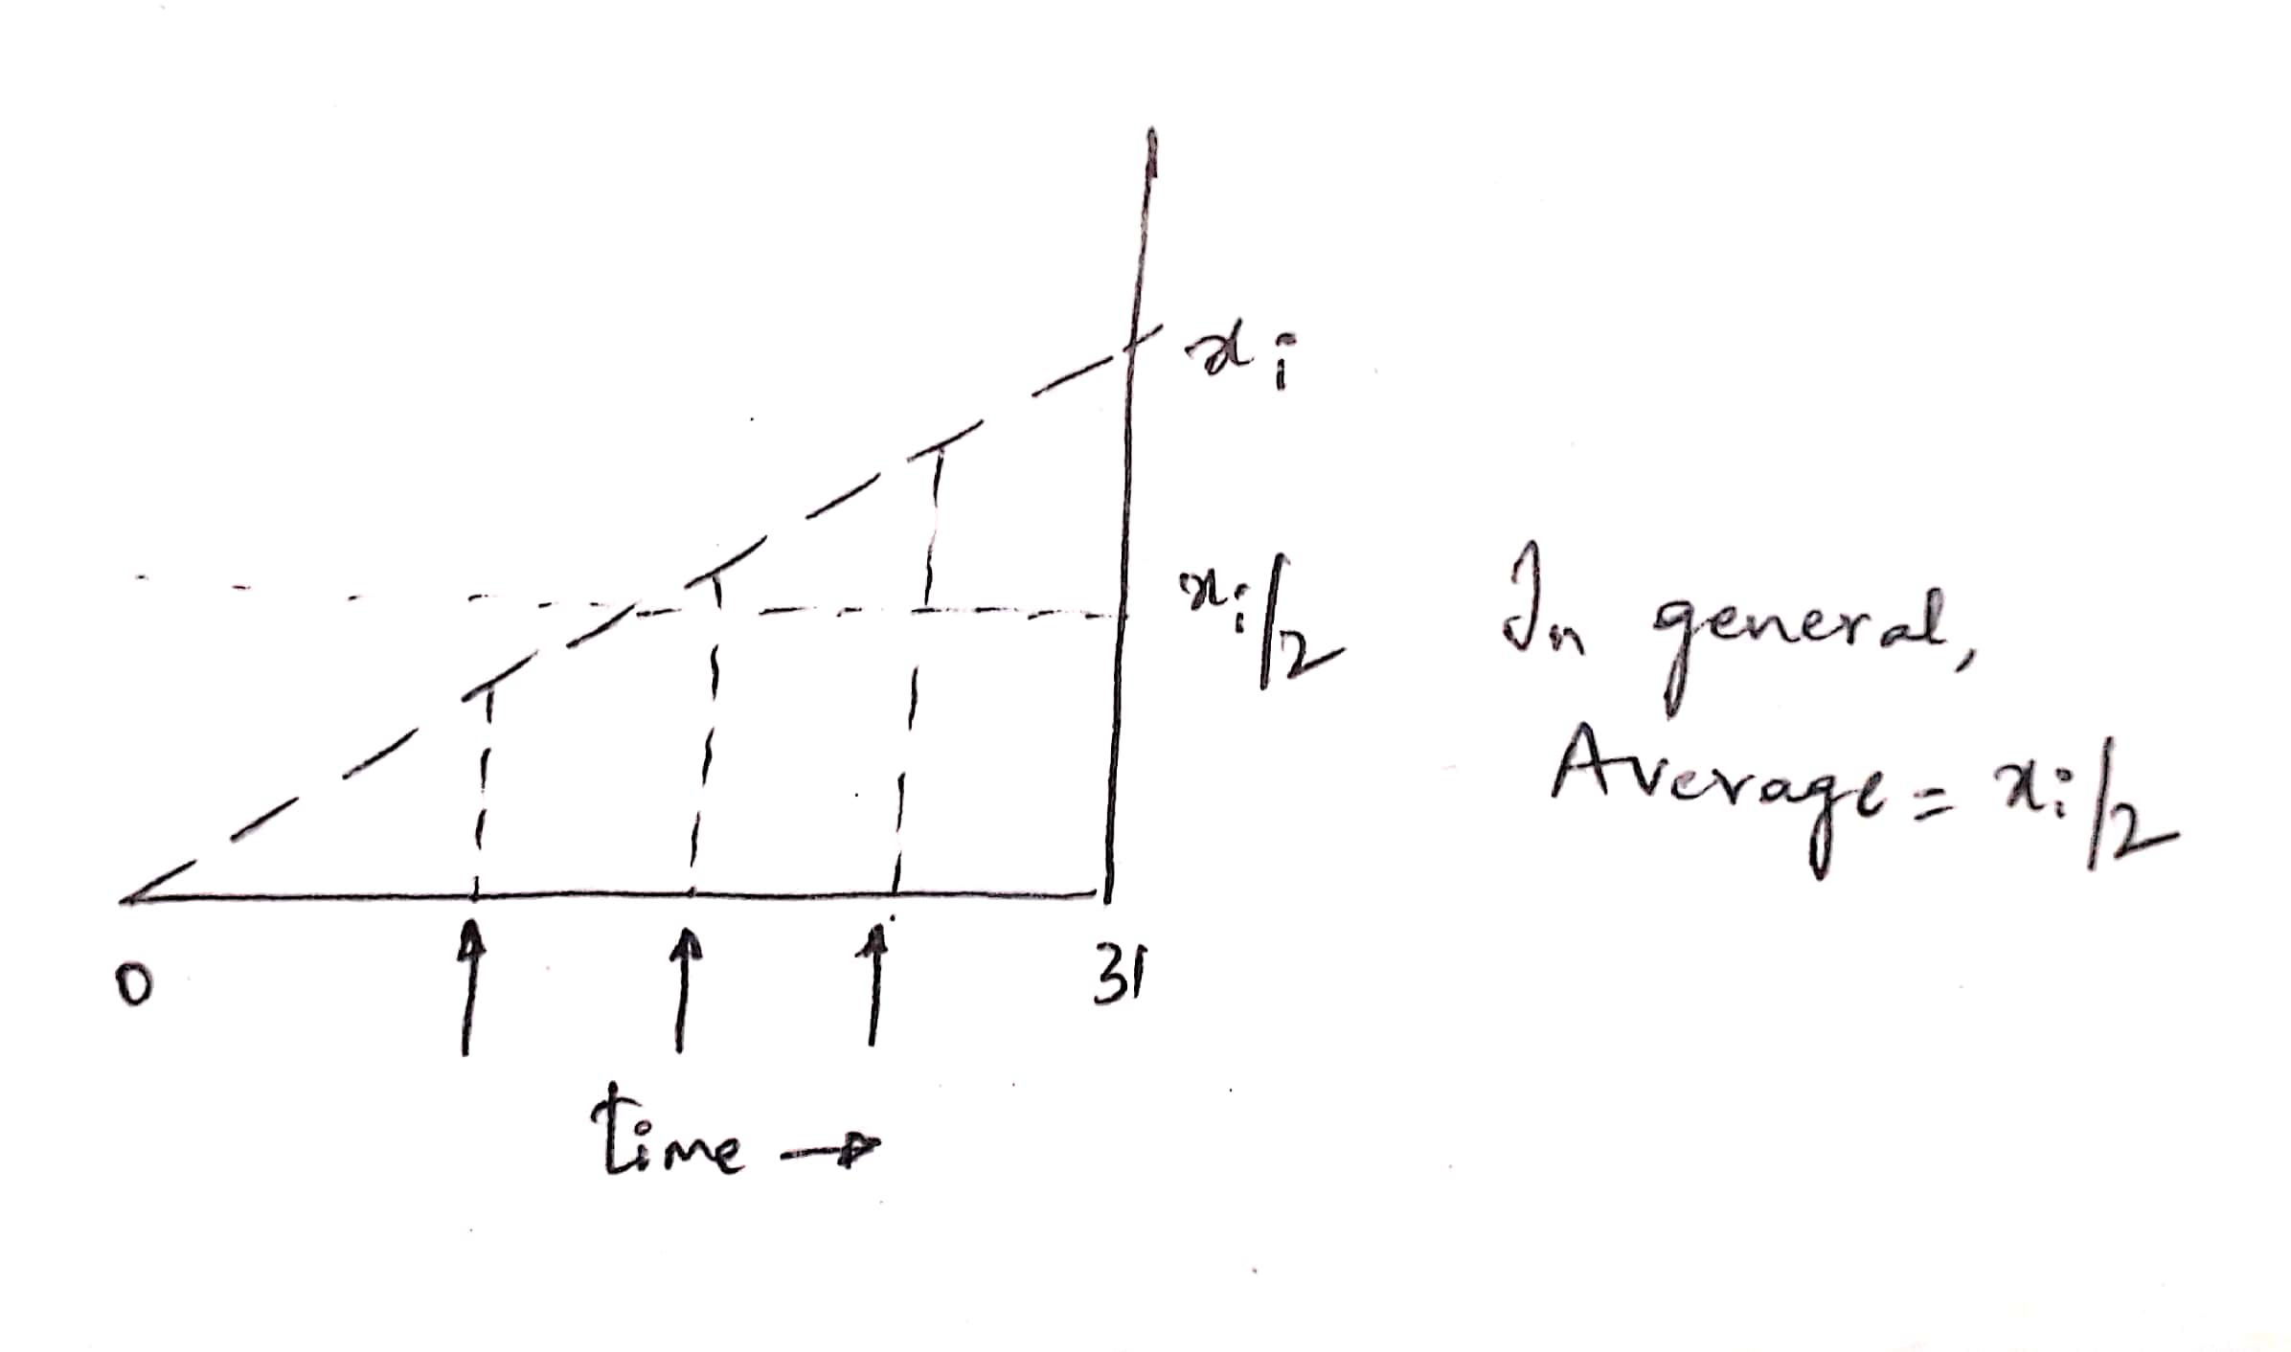

**Optimal Solution.** The following is the solution obtained from Excel Solver.



The optimal ordering plan for the procurement department is 75 Bikes for Month 1, 0 Bikes for month 2 and 35 Bikes for month 3.

